Source code:

code for historical places home page:

<html>

<head>

<title>Historical Places </title>

<style>

*{

box-sizing: border-box; padding:0; margin:0;

}

.container { display:flex; justify-content:center; flex-wrap:wrap;

}

body{ background:rgb(27,27,27);

}

.card{ background:white; width:270px;

margin:10px; border-radius:15px;

}

.card-image{

height:170px; margin-bottom:15px; background-size:cover; border-radius:15px 15px 0 0;

}

.img-1{

background-image:url('taj.jpg')

}

.img-2{

background-image:url('suntemple2.jpeg')

}

.img-3{

background-image:url('redfort.jpeg')

}

.img-4{

background-image:url('mysore.jpeg')

}

.card p{ padding:10px;

}

.card a{

background-color:black;

color:white; padding:15px 20px; display:block; text-align:center; margin:20px 50px; text-decoration:none;

}

.card:hover{

background-color:rgb(62,62,62);

color:white; cursor:pointer; transform:scale(1.03); transition:all is ease;

}

h2{ padding:10px;

}

h1{ color:blue;

}

.abc{ color:green;}

</style>

</head>

<body>

<h1><center> HISTORICAL PLACES IN INDIA</center></h1><br>

<section class="container">

<div class="card">

<div class="card-image img-1"></div>

<h2>Tajmahal</h2>

<p>The Taj Mahal is one of the seven wonders of the world and is considered to be the most popular tourist attraction in the country. A symbol of love, the Taj was built by Mughal Emperor Shah Jahan for his queen Mumtaz. Tagore described the Taj as a "teardrop on the cheek of eternity". The monument attracts a lot of tourists all around the year.

</p>

<a href="Tajmahal.html">READ MORE</a> </div>

<div class="card">

<div class="card-image img-2"></div>

<h2>Sun Temple</h2>

<p>Dedicated to Lord Surya, this 13th-century temple is an architectural marvel and the quintessential example of Oriyan form of architecture. It is believed that the temple was constructed by King Narasimhadeva I of Eastern Ganga Dynasty. The shape of the temple is of a massive chariot with sumptuously engraved stone wheels, pillars and walls. A major part of the structure at present is in ruins.</p>

<a href="sun temple.html">READ MORE</a>

</div>

<div class="card">

<div class="card-image img-3"></div>

<h2>Red Fort</h2>

<p>The Red Fort was the official seat of Mughal rule and authority from 1648 onwards, when the 5th Mughal emperor, Shah Jahan, decided to move the capital of the empire from Agra to Delhi. Constructed using red sandstone, it remains one of the architectural marvels of the Mughal era. In 2007, it became a UNESCO World Heritage Site.

</p>

<a href="redfort.html">READ MORE</a>

</div>

<div class="card">

<div class="card-image img-4"></div>

<h2>Mysore Palace</h2>

<p>The former residence of the royal family of Mysore, the Mysore Palace is an extremely breath-taking example of the Indo-Saracenic style of architecture. It was built in the year 1912 for the 24th Ruler of the Wodeyar Dynasty and is till date one of the biggest palaces in the country. It's one of the most popular and well-known tourist attractions in India.

</p>

<a href="mysore palace.html">READ MORE</a>

</div>

</section>

<div class="abc"><center><h2>Designed and Developed by </h2>

<h3>-P.Dhanush</h3></center></div>

</body>

</html>

Code for Taj Mahal web page:

<html>

<head>

<title> Tajmahal</title>

<style>

</style>

</head>

<body>

<h1><center>TAJ MAHAL</center></h1><br>

<img src="taj.jpg"" width="1300" height="500" style="width:100%">

<h3>History of Taj Mahal</h3>

<p>The Taj Mahal was built as a mausoleum by Shah Jahan for his wife Mumtaz Mahal, who died while giving birth to their 14th child in 1631. Her death left the emperor completely heartbroken, and his hair is said to have turned grey overnight. The construction of the Taj began in 1632. Th main building was completed in eight years, but the whole complex was not completed until 1653. Soon after the construction was completed, Shah Jahan was overthrown by his son Aurangzeb and imprisoned in the Agra Fort. For the rest of his life, he could only gaze at his wondrous creation through a window. Shah Jahan died in 1666, after which his mortal remains were buried here alongside Mumtaz.

</p>

<p>Over 20,000 people from all over Indian and Central Asia worked on this striking building. Specialists were brought from as far away as Europe who produced the beautiful marble screens and marble inlay (pietra dura) which is made of thousands of semi precious stones. Taj Mahal was designated as a World Heritage Site by UNESCO in 1983. It looks as pristine today as it was first constructed. The monument underwent a massive restoration project in the early 20th century.</p>

<h3>Inside Taj Mahal</h3>

<p>The Taj Mahal can be accessed through east, west and south gates. Inside the grounds, the ornamental gardens are set on the classic Mughal charbagh lines (formal Persian garden). The monument stands on a raised marble platform at the northern end of the garden, facing its back to the Yamuna River. Its raised position is a masterstroke design as it leaves only the sky as its backdrop. Each corner of the platform is graced with 40m high white minarets. Taj itself is made of semi-translucent white marble, inlaid with thousands of semi-precious stones and carved with flowers. The four indistinguishable faces of the Taj are in perfect symmetry, featuring impressive vaulted arches containing pietra dura scrollwork and the quotations from the Quran. The whole structure is topped off by four small domes.</p>

<p>The cenotaph of Mumtaz Mahal lies directly below the main dome. It is an elaborate false tomb which is surrounded by an elegant marble screen inlaid with various types of semi-precious stones, offsetting the symmetry of the Taj. The light enters the central chamber through finely cut marble screens. These tombs are false tombs as the real tombs of Mumtaz Mahal, and Shah Jahan lies in a locked room below the main chamber.</p>

<p>The complex houses a red sandstone mosque to the west which is a significant gathering place for the Muslims residing in Agra. There is an identical building to the east, the Jawab, which was built to maintain symmetry. Within the Taj lies the small Taj Museum which houses many original Mughal miniature paintings. Its primary attraction is a pair of 17thcentury ivory portraits of the emperor Shah Jahan and Mumtaz Mahal. It also has some Caledon plates which are said to split into pieces or change colour if the food served on them contains poison.</p>

<h3>Taj Mahal Garden</h3>

<p>The garden that beautifies the monument of love, beginning from the entryway and spreading across to the base of the mausoleum is one of the leading highlights of visiting Taj Mahal. The concept of this garden (popularly known as Paradise Garden), built in the Persian Timurid style, was brought in by Babur. A unique attribute followed while constructing this garden is the usage of the number four and its multiples. This was done as four is considered as the holiest number in Islam. The enchanting garden is divided into four parts, with two marble canals studded with the fountains occupying the centre. Each quarter portion of the garden has 16 flowerbeds each of which was planted with 400 plants. The Taj Garden abounds with lush trees, chirping birds, fruits, flowers and symmetry, signifying the abstract meaning of paradise. This quaint setting makes for a wonderful backdrop for those perfect shots.</p>

<h3>Best Time to Visit Taj Mahal</h3>

<p>The best time to visit Taj Mahal is unarguably the sunrise when it looks the most majestic. This is also the most comfortable time to visit because of fewer crowds. Another magical time to visit the Taj is the sunset. You can also visit it for five nights around the full moon. The entry tickets for this time is limited though, and it must be bought a day in advance from the Archaeological Survey of India office.</p>

<h3>How to reach Taj Mahal</h3>

<p>Reaching Taj Mahal and getting around Agra can be done in tongas, electric buses and tempos. There are also auto rickshaws and state buses. In order to minimise the effects of pollution on the monument, vehicles are not allowed in the vicinity of Taj and need to be parked in the parking lots that are at a short distance from the mausoleum. There are nonelectric tourist buses for visitors from the parking lot.</p>

<p>Taj Mahal and the Agra Fort are quite close to each other, and if it's not too sunny you can just walk between the two. Otherwise, there are a lot of autos and battery-powered rickshaws plying between the two major monuments that charge a minimum amount.</p>

<center><h3>Designed and Developed by </h3>

<p>-P.Dhanush</p></center>

</body>

</html>

Code for Sun Temple web page:

<html>

<head>

<title> Sun Temple</title>

<style> h1{ color:blue;}

</style>

</head>

<body>

<h1><center>SUN TEMPLE</center></h1><br>

<img src="suntemple2.jpeg"" width="1300" height="500" style="width:100%">

<h3>History of Sun Temple</h3>

<p>Construction of the Sun Temple is credited to Narsimhadeva, a ruler of the Eastern Ganga Dynasty. It is assumed that the temple was built to commemorate the victory over Tughral Tughan Khan in 1255 CE. A common local legend, bound to be heard from your travel guide is the presence of a massive magnetic rod at the centre of the temple which interfered with the compasses of travelling ships causing wrecks which ultimately led to its collapse. The wheels of the Sun Temple are actually sundials which tell the time accurately. It was also known as 'Black Pagoda' because of its colour. The Konark Temple, as seen today was merely an entrance to the main temple back then which has fallen now.</p>

<p>Fascicle No 7 of Madala Panji (The Official Record Book of the Jagannath Temple) of Mukunda Deva (1551-1568 AD) records the cause of demolition as a result of invasion by Muslim Invader named Kala-Pahad (who is also incidentally claimed to be a Hindu Renegade) in 1568 AD, when he removed key structural supports of the monument and damaged the idols but the theory doesn't hold much ground. A later entry of the Madala Panji, in Fascicle No 6 of Raja Narasimha Deva, son of Raja Purusottama Deva (1621-1647), it becomes clear that the temple collapsed. The Fascicle notes that "In the 9th Anka of the reign of this Raja, the big lion, the Gaja Simha, on the eastern side of the Konark

Temple fell down towards the east, together with the Eastern Temple Wall. At this time the hands of puja image were broken, whereupon the entire country fell into great affliction." The entry further notes the shifting of the Chalanti

Prateema (The portable images) to the Jagannath Temple at Puri.</p>

<h3>Architecture of Sun Temple</h3>

<p>The Sun Temple built in a traditional Kalinga style of architecture has been made in the form of a massive chariot of the Sun God with twelve pairs of sumptuously engraved stone wheels, pulled by a set of seven horses. The temple is brilliantly slanted to the east so the first rays of sunrise forays the main entrance. The entrance is manned by two huge lions on either side, both crushing a man and an elephant beneath. Erotica, monsters, beasts, warriors, and animals are carved on the outer walls all around the temple. Sculptures are vividly similar to the ones at Khajuraho Temple in Madhya Pradesh. The main sanctum (Vimana) which was a massive seventy meters tall fell back in 1837 due to weak soil and the huge weight of the structure. An audience hall about 30 meters high still stands and is the last of the main surviving structures.

</p>

<p>Archeologists have also discovered a couple of other temples from 11th century around the main temple. One of them is known as Mayadevi Temple dedicated to one of the Sun god's wife and the other is assumed to be dedicated to Lord Vishnu. Konark SUn Temple has an abundance of erotic sculptures known as 'Mithuna' sculptures. There are no concrete explanations for the presence of these sculptures on the outer walls of the temple. A common legend is that the sculptures were built after the Kalinga War to promote love making due to the huge loss of lives. The surviving structures on present-day apart from the entrance are the 'Nata Mandir' (Dancing Hall) and 'Bhoga Mandapa' (Dining hall). The Nata Mandir refers to the 'Devdasis' tradition when dancers lived inside the temple complex dedicating their entire life to dance forms like Odissi and Bharatnatyam. Sculptures, erotic carvings on walls and images of wars, animals, and warriors are found everywhere. Konark Sun Temple is the third link of the state's golden triangle with Jagannath Puri Temple as the first link and Bhubaneswar as the second.</p>

<p>Originally built on the sea bank, it is now a considerable distance away from the seashore. A Navgraha Temple (Nine Planets Temple) is also located just outside the Sun Temple; it contains a huge black coloured slab with idols of the nine planets made of chlorite stones. The slab was initially kept above the main doorway but is now kept inside the Navgraha Temple. Waking through the temple structure one is likely to feel like they are lost in the pages of history.</p>

<h3>Best Time To Visit Sun Temple</h3>

<p>Summers in Odisha are really humid and visiting the place during this season is ill-advised. September to March is the best place to visit the place, the temperature is pleasant and cool.

The Dance Festival is usually held in the month of February so you might want to plan your trip accordingly.</p>

<h3>How To Reach Sun Temple</h3>

<p>The Sun Temple is 35 kilometers away from Puri which is also the nearest railway station. The nearest airport is Bhubaneswar sixty kilometers away which is also the state's capital.

Regular buses and taxis ply from Puri which is an hour drive away. Parking spaces are aplenty if you are planning to come here on your own vehicle. Rates of private taxis range from INR 1000 to INR 1800 depending upon the vehicle you choose. Bus rates range from INR 250 to INR 400 depending upon the attractions you want to cover.</p>

<p> AIR: Biju Patnaik international airport in Bhubaneshwar is the closest airport. From here the distance to Konark is 64 kilometers. Taxis are available outside the airport.

</p>

<p>RAIL: Puri is the nearest rail network from where the distance to Konark is 15 kilometers. Puri is well connected to the rest of the country by railways. A taxi or a bus can be taken from the railway station to reach the Sun Temple.

</p>

<p>ROAD: One can take state transport bus from

Bhubaneshwar which is about 65 kilometers from Konark Temple.</p>

<center><h3>Designed and Developed by </h3>

<p>-P.Dhanush</p></center>

</body>

</html>

Code for Red Fort webpage:

<html>

<head>

<title> Mysore Palace</title>

<style> h1{color:blue;}

</style>

</head>

<body>

<h1><center>MYSORE PALACE</center></h1><br>

<img src="mysore.jpeg"" width="1300" height="500" style="width:100%">

<h3>History of Mysore Palace</h3>

<p>The Mysore Palace has a rich history attested to it. It used to be the residence of the royal Wadiyar family of Mysore from 1350 to 1950, for almost 600 years. During its lifetime, the palace had been built and rebuilt many times. In 1897, the then ruler of Mysore, Krishna Rajendra Wadiyar IV, ordered the restoration and reconstruction of the palace after a wooden palace was destroyed by fire at a wedding ceremony. Lord Henry Irwin, the British architect, was commissioned to replace the older palace which had gotten burnt during a fire in 1897. The palace's construction was completed in 1912 and cost an exorbitant amount of INR 41,47,913 at the time.

</p>

<p>In 1940, several renovations were made in the palace structure, which included the Public Darbar Hall.The descendants of the royal family continue to reside in one portion of the Mysore Palace, while most of the palace is now state-owned and converted into a museum. It's one of the most famous and well-known attractions in India attracting more than six million tourists annually.</p>

<h3>Architecture Of Mysore Palace</h3>

<p>The Mysore Palace is built in the Indo-Saracenic form of architecture which is an exquisite blend of Hindu, Muslim, Rajput and Gothic styles of architecture. The Indo-Saracenic architecture was an architectural revival movement by British architects in the 19th century, drawing elements from IndoIslamic and Indian architecture mixed with Gothic and Neoclassical styles. It is a three-storeyed stone palace with marble domes and has a 145 ft tall five-storeyed tower. There is a large garden surrounding the palace. Entry to the palace is through "Gombe Thotti" or Doll's Pavillion with traditional dolls of different times displayed and a wooden elephant decorated with gold. The kingdom's motto, "never be terrified" is written in Sanskrit on the entrance gate and the arch.

</p>

<p>It has three gates towards the east (opens only during the

Dasara celebrations for VVIPs), west (opens only during the Dasar celebrations), and south (for public). There are many secret tunnels from the palace cellar that lead to Srirangapatna and other confidential areas. The Mysore Palace faces the Chamundi hills as the maharajas of Mysore were said to be devotees of Goddess Chamundi. There are twelve temples inside the complex with construction time ranging from the 1950s to as back as the fourteenth century.

</p>

<p>The private hall or the "Ambavilasa" is a luxurious hall with doorway carved out of rosewood. The king used to hold private meetings with ministers here. The Darbar Hall or the "Diwan-I-Am" is a 155 ft high public hall which was used for public announcements and hearings.The royal throne inside the Diwan-I-Am; displayed to the public only during the Dasara celebrations is an artistic masterpiece with mesmerising artwork on the gold covered throne. The wedding hall or the Kalyan Mandapa is another massive octagonal shaped hall south of the palace with glass ceilings and glazed tile flooring. The ceiling is filled with intricate kaleidoscopic artwork.</p>

<h3>Best Time To Visit Mysore Palace</h3>

<p>The best time to visit the palace is around the time of Dussehra when the entire compound is beautifully decorated and lit, illuminated in a golden hue.</p>

<p>The palace is lit every Sunday and on all public holidays. </p>

<h3>How To Reach Mysore Palace</h3>

<p>Mysore Palace is located right in the heart of Mysore city. The Mufesal Bus stand is located just a couple of kilometres away from the palace. The KSRTC buses operate from this

bus stand at short intervals. You can then walk from the bus stand to the north gate or the east gate of the palace. Alternatively, you can hire an auto rickshaw from the bus stand to the palace gate. If you are travelling by train to Mysore, you can hire an auto rickshaw from outside the station to reach the palace.</p>

<center><h3>Designed and Developed by </h3>

<p>-P.Dhanush</p></center>

</body>

</html>

OUTPUTS:

Historical Places Homepage:

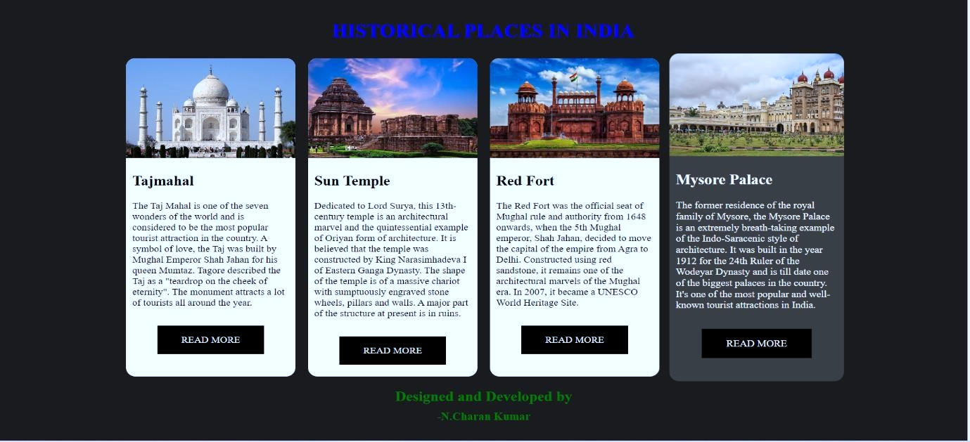



Tajmahal Webpage: When the user clicks on the read more option in tajmahal slot tajmahal web page will open showing the more information about the taj mahal.

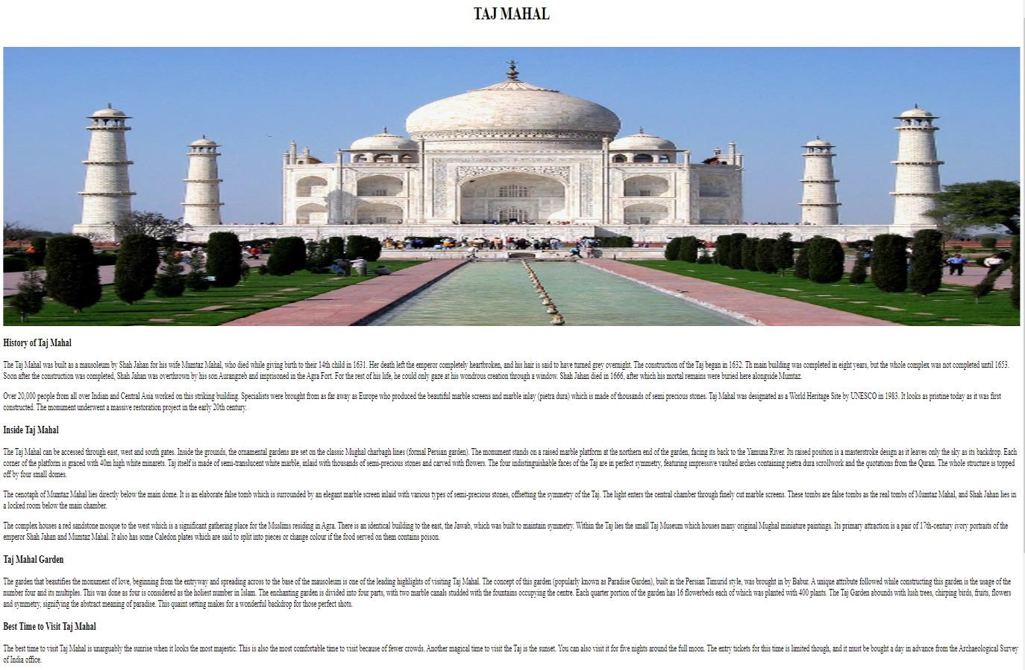

Sun Temple web page: When the user clicks on the read more option in Sun Temple slot Sun Temple web page will open showing the more information about the Sun Temple.

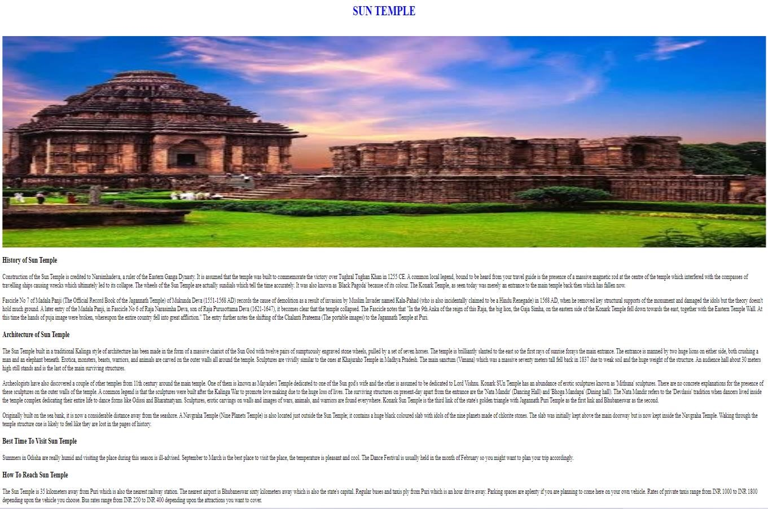

Red Fort Web Page: When the user clicks on the read more option in Red Fort slot Red Fort web page will open showing the more information about the Red Fort.

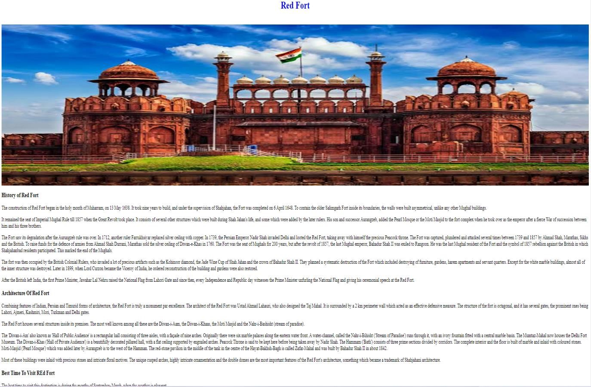

Mysore Palace Web Page: When the user clicks on the read more option in Mysore Palace slot Mysore Palace web page will open showing the more information about the Mysore Palace.

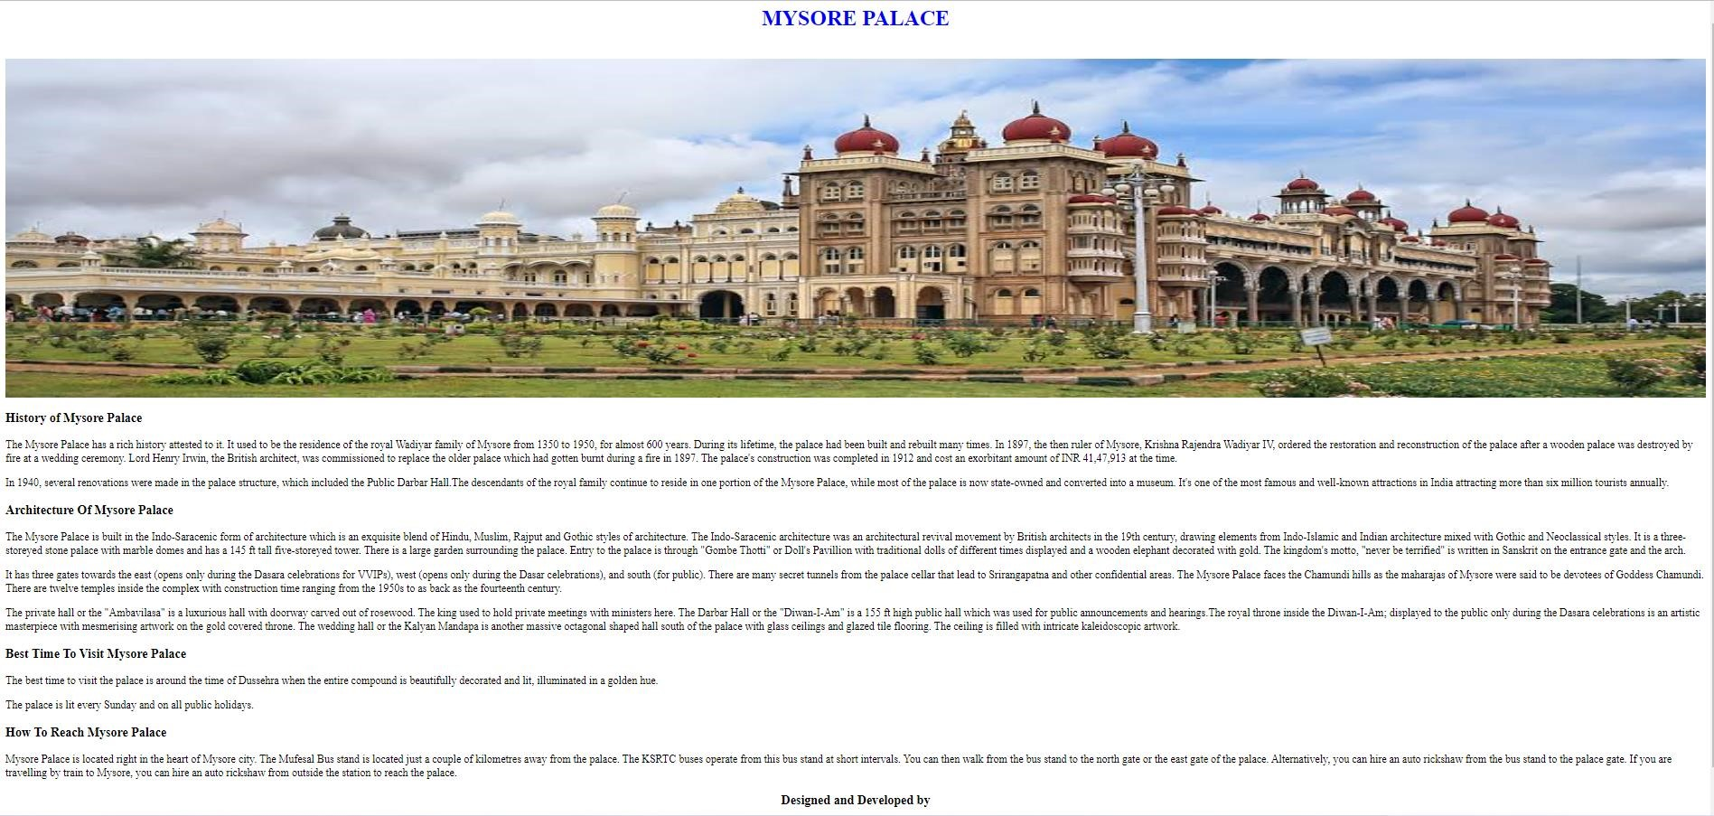

Designed and Developed by:

- P.DHANUSH